**After Action Report**/

**Improvement Plan** *(AAR/IP)*

<Insert Date of Report>

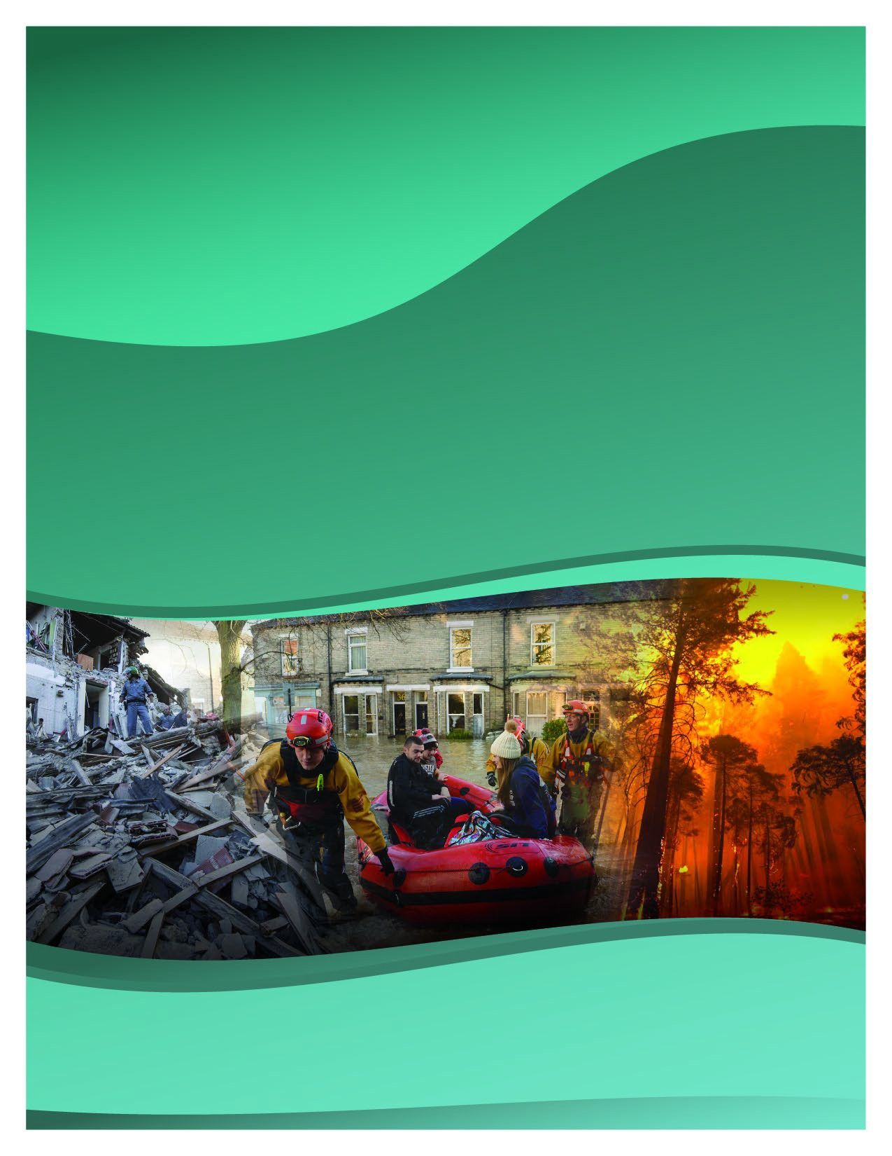

For Information, Contact:

**<INSERT ORGANIZATION NAME>**

**<Address>**

**<City, State Zip>**

This page intentionally left blank.

|  |  |  |  |  |  |  |  |  |  |  |
| --- | --- | --- | --- | --- | --- | --- | --- | --- | --- | --- |
| **<Insert Facility Name>**  **<Insert Exercise Name>**  **After Action Report (AAR)/ Improvement Plan (IP)** | | | | | | | | | | |
| **Section 1: Exercise Overview** | | | | | | | | | | |
| **Client**: <Insert Facility Name>  **Exercise Name**: <Insert Exercise Name>  **Begin**: <Insert Date> **Time**: <Insert Time>  **End**: <Insert Date> **Time**: <Insert Time> | | | |  | | | | | | |
| **Program:**  CDC/HHS Public Health Emergency Preparedness (PHEP) Grant  CMS Requirement  Emergency Management Performance Grant (EMPG) Hospital Preparedness Program (HPP)  Local Emergency Planning Committee  None (Not required by a Grant or Program | | | | | **Type of Event**  Actual/Real Event  Drill  Full-Scale Exercise (FSE) Functional/Command Post Seminar/Workshop Tabletop Exercise (TTX) | | | | | **Mission Focus of Exercise**  Continuity Mitigate Prevent Protect Recover Respond |
| **Exercise Scenario: (**Mark appropriate blocks)  **Natural Technological** | | | | | | | | **Core Capability** | | |
| Earthquake  Flood  Landslide  Severe Weather  Wildfire Winter Storm Other | | Communications (internet, cell tower)  Contamination Dam Failure Disease Outbreak  Hazardous Materials Power Failure Structural Integrity  Information Technological (IT) Other | | | | | | Bomb Threat  Cybersecurity  Evacuation  Health & Social Services Logistics & Supply Chain Mgt. Operational Communication Operational Coordination Planning  Public Health, Healthcare, & EMS Workplace Violence/Active Shooter Other | | |
| **Number of Participants and Agencies (be sure to include all governmental, tribal, and other private organizations)** | | | | | | | | | | |
| **Agency/Organization Name** | | | | | | **Participant(s) Name** | | | | |
|  | <Enter Agency/Organization Name> | |  | | |  | <Enter Participant(s) Name> | |  | |
|  | | | | | |  | | | | |
|  | | | | | |  | | | | |
|  | | | | | |  | | | | |
|  | | | | | |  | | | | |
|  | | | | | |  | | | | |
|  | | | | | |  | | | | |
|  | | | | | |  | | | | |
|  | | | | | |  | | | | |

|  |  |  |  |  |  |  |  |
| --- | --- | --- | --- | --- | --- | --- | --- |
| **Section 2: Exercise Design Summary** | | | | | | | |
| **Exercise Summary:** | | | | | | | |
|  | | | | | | | |
| **Exercise Purpose:** | | | <Enter Exercise Purpose> | | |  | |
| • | | | | | | | |
| • | | | | | | | |
| • | | | | | | | |
|  | | | | | | | |
| **Goals & Objectives:** | | | | <Enter Objective> |  | | |
|  | | | | | | | |
| 1. | | | | | | | |
| 2. | | | | | | | |
| 3. | | | | | | | |
|  | | | | | | | |
|  | **Section 3: Analysis of Exercise Objectives and Core Capabilities:** | | | | | |  |
|  | | **Ratings Definitions:** | |  | | | |
| • Performed without Challenges (P): The targets and critical tasks associated with the core capability were completed in a manner that achieved the objective(s) and did not negatively impact the performance of other activities. Performance of this activity did not contribute to additional health and/or safety risks for the public or for emergency workers, and it was conducted in accordance with applicable plans, policies, procedures, regulations, and laws.  • Performed with Some Challenges (S): The targets and critical tasks associated with the core capability were completed in a manner that achieved the objective(s) and did not negatively impact the performance of other activities. Performance of this activity did not contribute to additional health and/or safety risks for the public or for emergency workers, and it was conducted in accordance with applicable plans, policies, procedures, regulations, and laws. However, opportunities to enhance effectiveness and/or efficiency were identified.  • Performed with Major Challenges (M): The targets and critical tasks associated with the core capability were completed in a manner that achieved the objective(s), but some or all of the following were observed: demonstrated performance had a negative impact on the performance of other activities; contributed to additional health and/or safety risks for the public or for emergency workers; and/or was not conducted in accordance with applicable plans, policies, procedures, regulations, and laws.  • Unable to be Performed (U): The targets and critical tasks associated with the core capability were not performed in manner that achieved the objective(s). | | | | | | | |
| **1.**  Rating: | | | | | | | |
| • **Critical Task:** | | | | | | | |
| o **Task Met**: Yes/No | | | | | | | |
| o **Analysis**: [ Insert evaluation/analysis of why/why not the Critical Task was achieved. ] | | | | | | | |
|  | | | | | | | |
| • **Critical Task:** | | | | | | | |

|  |  |  |
| --- | --- | --- |
| o **Task Met**: Yes/No | | |
| o **Analysis**: [ Insert evaluation/analysis of why/why not the Critical Task was achieved. ] | | |
|  | | |
| • **Critical Task:** | | |
| o **Task Met**: Yes/No | | |
| o **Analysis**: [ Insert evaluation/analysis of why/why not the Critical Task was achieved. ] | | |
|  | | |
| **2.**  Rating: | | |
| • **Critical Task**: | | |
| o **Task Met**: Yes/No | | |
| o **Analysis**: [ Insert evaluation/analysis of why/why not the Critical Task was achieved. ] | | |
|  | | |
| • **Critical Task**: | | |
| o **Task Met**: Yes/No | | |
| o **Analysis**: [ | Insert evaluation/analysis of why/why not the Critical Task was achieved. | ] |
|  | | |
| **3.**  Rating: | | |
| • **Critical Task**: | | |
| o **Task Met**: Yes/No | | |
| o **Analysis**: [ Insert evaluation/analysis of why/why not the Critical Task was achieved. ] | | |
|  | | |
| • **Critical Task**: | | |
| o **Task Met**: Yes/No | | |
| o **Analysis**: [ | Insert evaluation/analysis of why/why not the Critical Task was achieved. | ] |
|  | | |
|  | | |

|  |  |  |  |  |  |  |  |
| --- | --- | --- | --- | --- | --- | --- | --- |
| **Section 4: Evaluator/Controller and/or Participant Feedback** (additional attachments as needed) | | | | | | | |
| <Insert feedback from Hot wash, and evaluator, controller, and/or participant feedback> | | | | | | | |
|  | | | | | | | |
| **Section 5: Overall Exercise Analysis** | | | | | | | |
| Overall this event identified major strengths and areas of improvement needed for incidents involving .  This exercise provided <Insert facility name> the ability to test their response to a realistic scenario of internal and external communications needs presented to us from a rapidly evolving incident identified as a Risk in the annual Hazard Analysis. | | | | | | | |
|  | | | | | | | |
| **STRENGTHS:** | | | | | | | |
| • [ | | | Insert any identified Strengths in bulleted list here (e.g. “Interagency Interoperability”) | | | | ] |
| • [ | | | Insert any additional identified Strengths in bulleted list here] |  | | | |
| **AREA(S) FOR IMPROVEMENT:** | | | | | | | |
| • [ | | Insert any identified Areas for Improvement in bulleted list here | | |  | | |
| • | Insert any additional identified Areas for Improvement in bulleted list here | | | | |  | |
|  | | | | | | | |
| **Section 6: Improvement Plan** | | | | | | | |
|  | | | | | | | |

|  |  |  |  |  |  |
| --- | --- | --- | --- | --- | --- |
| **Section 7:** | | **LESSONS LEARNED** |  | | |
|  | | | | | |
| **Section 8: CONCLUSION** | | | | | |
| The Exercise ( ) was designed to provide participants with an opportunity to assess  current capabilities to provide care for patients while performing the critical communication tasks required to respond  to a realistic public health emergency resulting from severe weather. Through assessment of these capabilities, participants identified strengths and weaknesses in their plans, and future training needs. | | | | | |
|  | | | | | **Date** |
|  |  | | |  |
|  | | | | | **Date** |