Required Emergency Preparedness Training Summary

Our Clinic participates in the Rural Health Clinic program (PL 95-210) which requires our medical practice to meet certain standards or conditions to continue our participation in the program. On November 16, 2016 new standards regarding Emergency Preparedness were finalized and require our clinic to do certain procedures to comply with these new regulations.
Our Clinic must develop and maintain an emergency preparedness plan that is reviewed and updated biennially on a documented community and facility-based risk assessment utilizing an all-hazards approach. We are required to develop policy and procedures implementing the Emergency plan including procedures to shelter in place patients and staff and protect the privacy of patients under HIPAA regulations during an emergency.
Our Clinic is required to develop a Communication plan to help coordinate emergency responses that must be updated biennially. This will require use to obtain and update your personal contact information each year which you can do by completing the contact information request in this document and dating the response.
We are required to implement initial and biennial training and annual testing program for our employees on Emergency Preparedness and document this training for review by the RHC inspectors. We are NOT required to use the same more rigid standards that state and local emergency management agencies are held to (HSEEP) but must develop an effective training and testing program within the constraints of our resources. During this training session we will review the procedures for a Fire Emergency, Severe Weather Plan, other common emergencies, and our Emergency Evacuation Plan.
We are required to annually test our Emergency Preparedness system by participating in a documented drill each year. One could be a community-based full-scale exercise, or it could be either a full-scale or Tabletop exercise. If a community-based full-scale exercise is not available, we may substitute and individual facility-based drill instead. As with all these processes, we must thoroughly document these exercises with signature pages for all participants and including any documents from the drills in our Emergency Preparedness manual. Many local, state, and community resources are available to help conduct these drills and you can find links for these resources at http://www.ruralhealthclinic.com/emergency-preparedness.
We have included an Emergency Preparedness Test that documents your understanding of the program. Please reread the bold underlined items as they will be on the test. You must score 70% on the test or you will be required to take the test again. Please complete the following test once you have viewed the training video at https://youtu.be/Xs5AKn2oIhI. Additionally, please complete the Communication Plan contact information so we contact you in case of an emergency and once you have been trained, please complete the information in the Initial and Biennial EP and RHC Quiz which is a series of 20 questions on our specific processes and procedures.

Emergency Preparedness - Training (upon hire & biennially)

Please answer each question related to Emergency Preparedness, sign, and turn in for Grading. Each person must score 80% or higher.
- _________True or False? RHCs must develop and maintain an emergency preparedness plan that is reviewed and updated biennially?
- _________True or False. The clinic has specific instructions to evacuate the clinic in case of emergencies which can be found in the Emergency Preparedness Policy and Procedure Manual
- ________True or False? Health Insurance Portability and Accountability Act (HIPAA) Privacy requirements are followed in emergencies although the clinic may tell Incident commanders or Emergency officials if a patient is located at the clinic.
- ________True or False? When assessing compliance with emergency training and testing requirements, the surveyor should review personnel or training records to verify that all staff completed initial and biennial training.
- ________True or False? Rural Health Clinics are required to participate in two drills every year to test the emergency preparedness system and document the participation of these drills in the Emergency Preparedness Policy and Procedure Manual.
- _________True or False? Emergency Preparedness is a condition of participation and RHCs must comply to participate in the rural health program. Failure to comply could result in removal from the RHC program.
- _________True or False? RHCs are required to develop and maintain an emergency preparedness training and testing program based on the standards set forth by state and local emergency management agencies (HSEEP)
- _________True or False? RHCs are required to develop a communication plan to support coordination of patient care within the facility, across health care providers, with state and local public health departments and emergency management agencies, and with systems to protect patient health and safety in the event of a disaster.
- How often must an RHC review and update their communication plan contact information?
  - Monthly
  - Quarterly
  - Annually
  - When information changes and at least once every two years.
- _________True or False? RHCs are required to develop policies and procedures for patients and staff to shelter in place during and emergency; however, RHCs are not required to maintain supplies for several days as a hospital or nursing home would.

Name | Title | Date | Score

Emergency Preparedness - Initial Training
Answer Key for Test
1. True
2. True
3. True
4. True
5. False (only 1 drill effective November 29, 2019
6. True
7. False (RHCs are not held to HSEEP standards, but must test the system annually)
8. True
9. d.
10. True

Answers are based upon the Emergency Preparedness Basic Surveyor course developed by CMS. This seventeen-hour course is a great resource to learn more about Emergency Preparedness. See Link provided below:

https://qsep.cms.gov/pubs/CourseMenu.aspx?cid=0CMSEmPrep_ONL
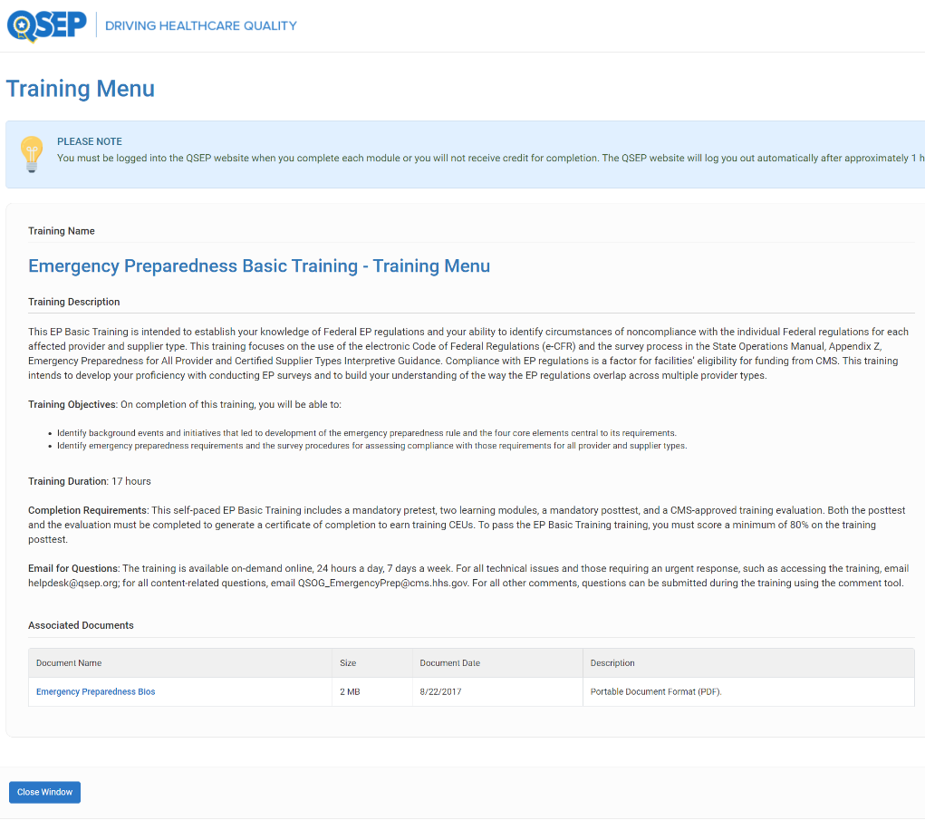

Emergency Preparedness Communication Plan

Employee Critical Phone Numbers

Date
Name
Title
Address
Cell Phone – Primary Telephone
Secondary Telephone
Email Address
Emergency Contact Name
Emergency Contact Phone Number

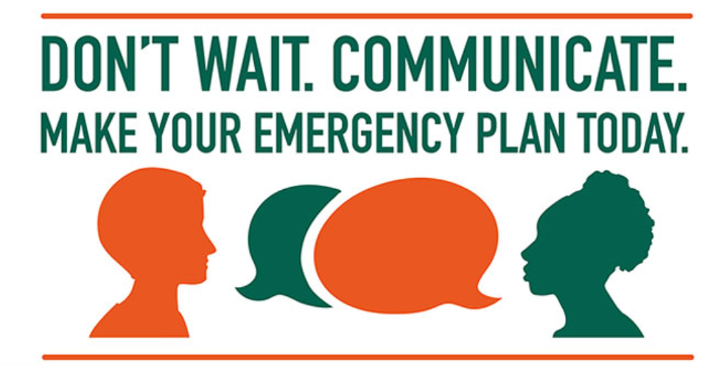
Please provide your emergency contact information for our Emergency Preparedness Communication plan and inform us any changes that may occur in the future.

Initial and Biennial RHC & EP Training Quiz
Name:_____________________________________ Date:___________________
- Who is the Medical Director of the clinic? ________________________________________________________________________
- Where can you find the Emergency Preparedness Policy and Procedures?
________________________________________________________________________

- If a patient checks in, but a provider has yet to arrive, what is the protocol?
________________________________________________________________________
- Describe how a life-threatening medical emergency is handled.
________________________________________________________________________
- How is a life-threatening medical emergency handled a provider is not yet onsite?
________________________________________________________________________
- If you smelled smoke, what would you do?
________________________________________________________________________
- Who decides when to evacuate the clinic?
________________________________________________________________________
- Who is in charge in case of an emergency? What if that person is not here?
________________________________________________________________________
- Where can you find a list of contact information for all clinic staff?
________________________________________________________________________
- Do we have a list of contacts for all local, state, and federal EMA contacts? Where is it
located?
________________________________________________________________________
- Where are the clinic evacuation maps located?
________________________________________________________________________
- Describe how multi-dose vials and single-dose vials are to be stored, labeled, and administered?
________________________________________________________________________
- Where are the sample medication logs located?
________________________________________________________________________
- Who is responsible for destroying expired sample medications?
________________________________________________________________________
- How are expired sample medications disposed of?
________________________________________________________________________

- Do you know where the clinic's organizational chart is located?
________________________________________________________________________
- Who is your direct supervisor?
________________________________________________________________________
- Do you know the clinic's delegations of authority? Who do you report to if your supervisor or the Office Manager is absent?
________________________________________________________________________
- Who is the first person you should report emergency events to?
________________________________________________________________________

- What is the clinic's handwashing policy?
________________________________________________________________________

